Router IP Address Configuration

Project Overview

This project demonstrates the configuration of IP addresses on a Cisco router
using Cisco Packet Tracer.

The objective was to assign IP addresses to router interfaces, configure
network connectivity, and verify communication between connected networks.

Technical Specifications & Tools

* **Software:** Cisco Packet Tracer v8.x
* **Hardware Simulated:** Cisco ISR 4331 Router
* **Protocols:** IPv4, ICMP

Topology Diagram
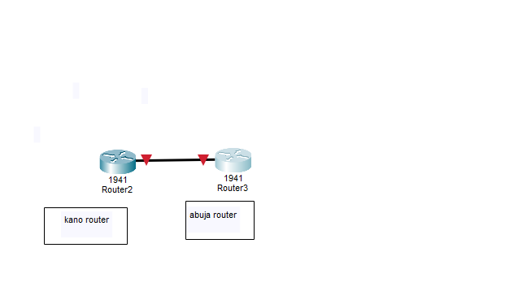

*Place an exported PNG diagram of your Packet Tracer topology below:*

![Network Topology](docs/network_topology_diagram.png)

Network Design Details

| Interface | Network Address | IP Address Assigned | Subnet Mask |
|-----------|-----------------|---------------------|-------------|
| GigabitEthernet0/0/0 | 192.168.1.0/29 | 192.168.1.1 | 255.255.255.248 |
| GigabitEthernet0/0/1 | 192.168.2.0/29 | 192.168.2.1 | 255.255.255.248 |

Key Implementation Steps

1. **Router Interface Configuration:**

Configured IP addresses on router interfaces:

